**Anonymous Services.**

**What are anonymous services in our app?**

“Anonymous services” is a feature, which will encourage users to ask for services, sometimes users may feel embarrassed to ask for a question, or showing that they are ignorant of a certain fact or subject.

The main idea of “Anonymous services” is to not reveal the identity of the asker, when he asks for a service, that doesn’t require interaction in the real word, or has any money in it, in order to avoid any bad effect that may result of letting the asker asks anonymously.

So whenever a user asks for a free service, the anonymous service option, will appear to him.

**Why anonymity?**

Our idea of anonymous services is heavily inspired by the following paper **“Why Do People Seek Anonymity on the Internet? “** for the author “Ruogu Kang” from the department of psychology in Carnegie Mellon university, published in 2013.

The study states that: “Anonymity lifts inhibitions and can lead to unusual acts of kindness or generosity, or it can lead to misbehavior, such as harsh or rude language and acts that are illegal or harmful. People use the protection of anonymity to reduce the social risks of discussing unpopular opinions and taboo topics, and to create different personas online than they exhibit offline”

**The study interviewed 44 participants, 23 women and 21 men**. They were using different websites such as Amazon Mechanical Turk, Craigslist, and university forums.

They told recruits that They were interested in online anonymity and asked them to participate if they had ever used the Internet anonymously.

All of the interviewees said they used the Internet frequently, and had at least one prior experience with anonymous browsing or another type of anonymous online activity.

Interviewees were from the United States (15), mainland China (14), Taiwan (9), Hong Kong (1), the Philippines (1), the United Kingdom (1), Romania (1), Greece (1), and Ethiopia (1).

Their ages and occupations varied widely; there were students, employees, and retirees. Interviewees reported a range of technical computing skills from practically none to advanced; one interviewee was an IT manager and another had a university degree in network security.

**Anonymous Activities Examples from the study:**

The study concluded this ***very interesting result that will be illustrated in the table below***, and that is extracted from many interviews that were done by the study makers, so let’s take a look at it and analyze it together, in order to get insight of the anonymous activities nature on the internet:

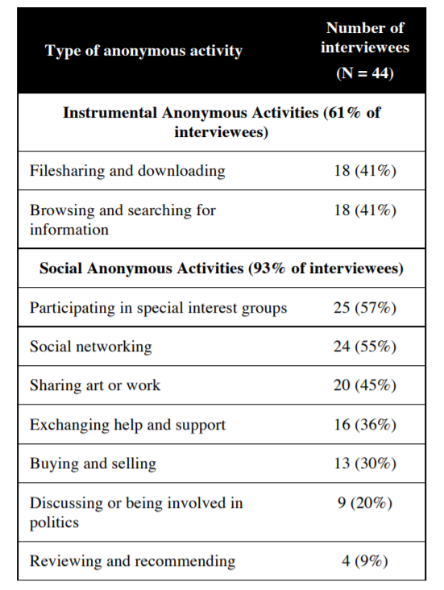

The study found that the majority of interviewees were engaged in social activities such as participating in

* Special interest groups.
* Exchanging help and support.
* Buying and selling.
* Reviewing and recommending.

All these activities are very important activities in our app, and they are from the major activities, that we are concerned with inside the app.

**How anonymity can eliminate the presence of fake profiles?**

Although social networking generally requires using one’s real identity, ***half of the interviewees reported using fictitious profiles to go on social networking*** or dating sites, or used false personal information when chatting online. Some interviewees used different social network profiles to separate the information they shared with different groups of people.

***An example of this*** is a teacher who was very active in a fandom group, and often posted fan fiction online.

She wanted to keep in touch with other members of that community, but she was afraid that she might be criticized if her family or her boss found out about her writing because it was not “real” fiction.

She therefore maintained two Facebook accounts, one under her real name for family and coworkers and one under a fictitious name for fandom friends.

One of the interviewees also said the following:

***“The reason I won't use my real name is to not connect my real life with the online community… I don’t want my supervisors and colleagues to know about the other side of my life, since that may make my image look bad”***

*So you can see how we solved such problem in our app, we don’t won’t this to happen in the app, which is to let someone make a fictitious profile, or to use false personal information, so we chose to do the following.*

Enabling users to be anonymous, while they are using their real profiles is a key solution from our perspective to solve this issue.

**The effect of anonymity on rating and reviews:**

Also another very important aspect is to consider the following: when the study came to the points of **rating and reviews:**

* Four participants anonymously posted their views about products and services. They mentioned their concerns about not knowing who would access their reviews and having their reviews stored online forever.
* They sought anonymity to avoid negative reactions from the subjects of the reviews or from people with opposing views.

One woman explained that she always signed her postal letters with her real name because they were addressed to one person or organization, but that she preferred to write anonymously when online.

***“I posted a very bad review [of a restaurant]. And I guess I did that [anonymously]. I live in a small town, so I certainly didn’t want to put my real name, although I would have no problem speaking face-to-face with the restaurant owner … If you speak to somebody face-to face, you know who you spoke to. But when it’s online, you’re really potentially speaking to billions of people, and the information will last”***

So it’s obvious that anonymity will help the asker to give the helper a real review even it’s sometimes a bad review.

**Do both Askers and Helpers have to be anonymous?**

We took the approach of letting the asker only being anonymous, and preventing the helper from doing so, this is to make sure that the asker will trust the answer of the helper, and to let the asker make sure that the helper have the enough skills to answer the questions, so he can see his profile, and his previous reviews.

**How we implemented this in our app?**

1-Requesting anonymous services:

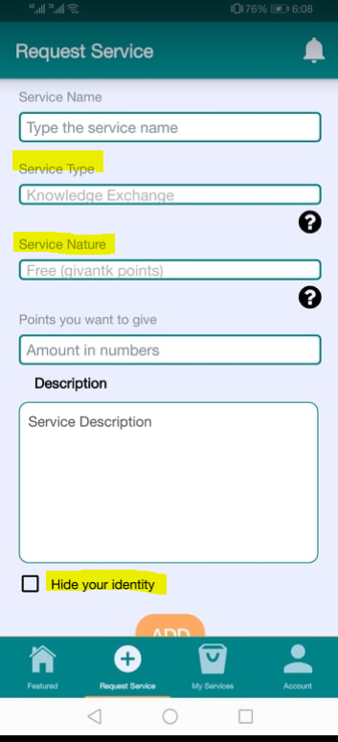

The following screen has 3 related things to anonymous services,

This is the screen, where users can request services.

The first thing related to anonymous services is choosing the service type, which is chosen here as (Knowledge Exchange) and this is the only type of services that you can request it anonymously.

In the other types as (Everyday services and Reaching the community) askers can’t ask for anonymous services, because these are services that depend on real life interaction (offline interaction), not only online interaction.

The second thing related to anonymous services is the service nature, which is whether free or paid, and as we said before, anonymous services will be used in the app in case of free services only, for ensuring safety for both sides the asker and the helper.

The third thing related to anonymous services is the (hide identity option) as it’s just an option, not an obligatory thing.

2-Anonymous everywhere:

We made sure that the asker of the service will be anonymous everywhere, and these are some examples:

*In the featured screen:*

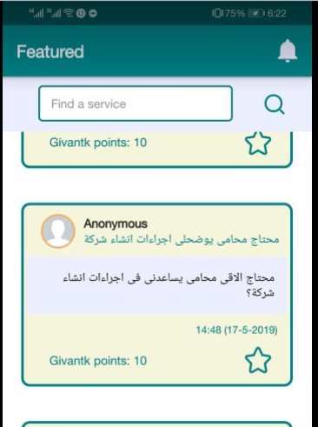

Inside the service:

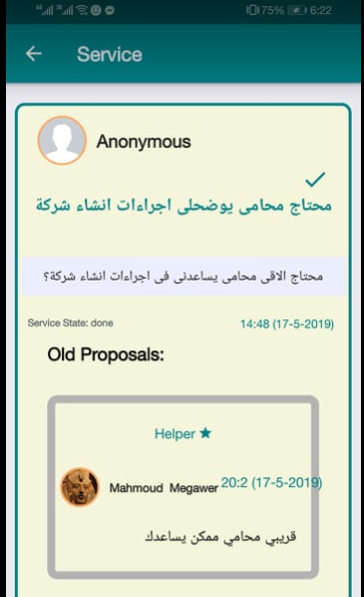

Inside Reviews:

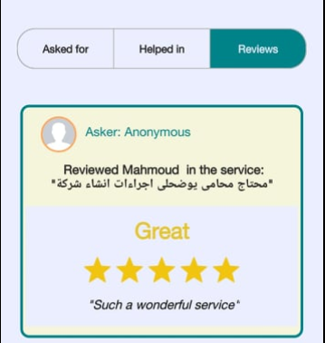

Inside chat:

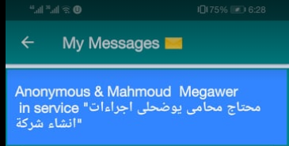

And also anonymity is provided in the push notifications.